THE OPEN UNIVERSITY OF SRI LANKA
DEPARTMENT OF ELECTRICAL & COMPUTER ENGINEERING
Bachelor of Software Engineering Honours
EER4189 - Software Design in Group

PROJECT PROPOSAL: AUTOMATED EQUIPMENT RENTAL & RENTAL CONTRACT MANAGEMENT SYSTEM
Target Client: T.P. Sound & Musical Gear Rentals

Project Group Members:
- Student 01: P.A.Y. Ekanayake | Reg No: 424705860
- Student 02: S.D.K.K. Saputhanthri | Reg No: 324703649
- Student 03: B.G.N.H. Bokanda | Reg No: 424704542
- Student 04: W.K.V. Dilthara | Reg No: 324702072

Project Supervisor: PT Rukshima Dabare

SECTION 1: INTRODUCTION & BACKGROUND
  - Project Executive Summary

- This project proposes the development of a web-based Automated Equipment Rental & Rental Contract Management System tailored for Small and Medium Enterprises (SMEs) in the event production and music industry. The proposed solution digitizes inventory tracking, automates rental contract management, prevents item overbooking, and calculates late return penalties automatically.
1.2 Client Profile & Domain Context
- Business Name: T.P. Sound & Musical Gear Rentals
- Proprietor: Mr. Tony Prabath (Owner & Music Instructor)
- Location: Kuruwita
- Business Type: Sole Proprietorship (Single Owner SME)
- Core Business Activities: Renting high-value musical instruments (electric/bass guitars, drum kits, keyboards), sound amplification systems (combos, stacks), and PA gear for local live shows, musical bands, and student performances.
- Current Operational Mode: The business operates entirely on manual paper logbooks to manage item availability, customer agreements, deposits, and return dates.
SECTION 2: PROBLEM STATEMENT & PROJECT OBJECTIVES

2.1 Problem Statement
Small and Medium Enterprises (SMEs) in the music and event equipment rental domain, such as T.P. Sound & Musical Gear Rentals, rely heavily on traditional paper logbooks and manual tracking. This manual operation leads to critical operational bottlenecks:
- Double-Booking Collisions: Popular musical instruments (e.g., drum kits, synthesizers) and live sound gear are frequently overbooked during peak weekend gig seasons.
- Loss of Revenue via Inaccurate Late Fees: Equipment returned past the agreed contract deadline causes domino-effect delays for subsequent client rentals, while manual late fee calculation frequently results in human error.
- Untracked Package Bundles: Gear hired as full stage packages (mixers, speakers, mic sets) lacks itemized component tracking during returns, leading to missing accessories.

2.2 Project Objectives
- To Automate Inventory Tracking: Implement a real-time dynamic inventory catalog to prevent booking overlaps.
- To Digitalize Contract & Rental Agreements: Automatically generate PDF rental contracts outlining clear damage policies and terms.
- To Automate Late Return Penalty Calculations: Integrate an automated fee calculator based on contract duration and delay days.
- To Provide Centralized Booking Management: Develop an intuitive dashboard for the sole proprietor to manage active rentals, returns, and client records efficiently.

SECTION 3: SIMILAR EXISTING SYSTEMS

3.1 Analysis of Existing Rental Management Solutions
To design an optimized system for T.P. Sound & Musical Gear Rentals, several commercial rental software solutions were evaluated. While existing global platforms provide robust feature sets, they present significant gaps when applied to local SME music equipment rental workflows.
- Booqable: A popular cloud-based rental management platform. It offers online booking, calendar scheduling, and inventory tracking.
  - Limitation: High monthly subscription cost in USD, lacks localized SMS notification integration, and offers overly complex setup steps for single-owner local shops.
- EZRentOut: An enterprise-grade asset and equipment tracking software focused on construction and heavy machinery.
  - Limitation: Over-engineered for musical instrument bundles and lacks simple automated contract generation for event-based rental windows.
- Manual Logbook & Spreadsheet Systems: The current status quo used by regional music shops in Sri Lanka.
  - Limitation: High risk of double-booking, manual calculation errors for late fees, and complete lack of dynamic contract tracking.

3.2 Comparative Analysis Table
Feature / Criteria | Booqable | EZRentOut | Manual Logbooks | Proposed System (T.P. Gear)
Real-time Availability Calendar | Yes | Yes | No | Yes
Automated Contract Generation | Basic | Advanced | No | Yes (Tailored for Music Gear)
Automated Late Fee Calculation | Yes | Yes | Manual/Error-prone | Yes (Dynamic Rates)
SME Cost / Affordability | High (Monthly USD) | High (Enterprise) | Low | Low (Tailored for Local SMEs)
Ease of Use for Single Owner | Moderate | Complex | Simple | Very Simple & Intuitive

3.3 Key Differentiator of Proposed System
The proposed system bridges the gap between expensive enterprise tools and unreliable manual logbooks by delivering a lightweight, cost-effective solution specifically designed for localized event equipment and instrument rental management.

SECTION 4: PROPOSED SOLUTION

4.1 Proposed System Overview
To address the operational challenges faced by T.P. Sound & Musical Gear Rentals, the proposed Automated Equipment Rental & Rental Contract Management System provides a web-based management application. The system streamlines rental operations through four core functional modules:
- Inventory & Availability Management: Maintains a dynamic equipment catalog with status indicators (Available, Rented, Under Maintenance) and an integrated booking calendar to eliminate double-booking.
- Contract & Agreement Automation: Automatically generates standardized PDF rental contracts containing itemized gear lists, rental periods, security deposit amounts, and damage/loss liability clauses.
- Dynamic Fee & Penalty Calculation Engine: Computes rental fees based on usage duration and automatically calculates late return penalties according to predefined delay rates upon item check-in.
- Client & Booking Management Dashboard: Provides a centralized dashboard for the proprietor to view active rentals, track upcoming return deadlines, and review client rental histories.

4.2 High-Level Use Case Diagram
The system identifies two primary user roles: Proprietor (Mr. Tony Prabath) and Customer (Bands / Event Organizers).
- Customer Capabilities: Browse the equipment catalog, submit rental bookings (which automatically includes checking equipment availability), and view booking status alongside contract details.
- Proprietor Capabilities: Manage equipment inventory, approve or reject booking requests, process check-outs (which automatically generates PDF contracts), process check-ins (which extends to calculating late fees and recording equipment damage if required), and view analytical reports.
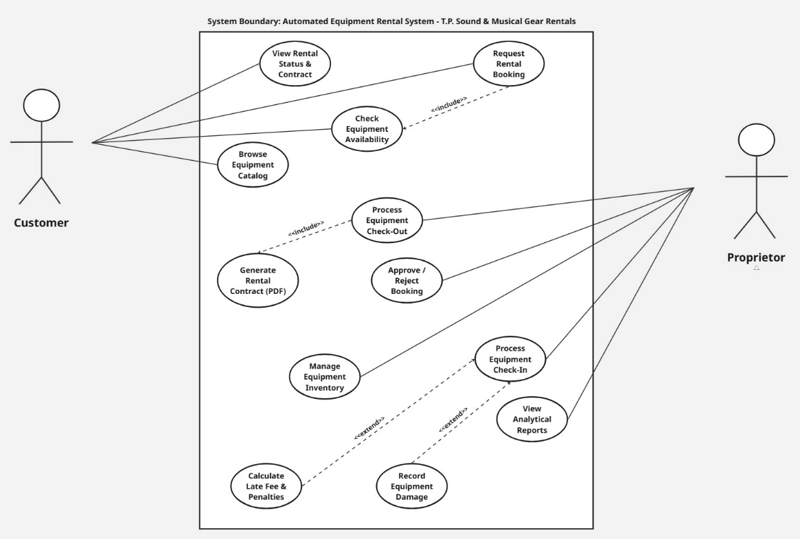
Figure 4.2: Use Case Diagram for T.P. Sound & Musical Gear Rentals
SECTION 5: TECHNOLOGY PLAN

5.1 Technology Stack & Architectural Overview
The proposed system utilizes a lightweight, modern, full-stack web architecture designed for fast performance, high reliability, and zero subscription costs for the SME client.
- Backend Technologies and Tools: Node.js with Express.js
Provides an asynchronous, event-driven runtime environment for handling server-side business logic, dynamic REST APIs, date-based booking calculations, and PDF contract generation (via PDFKit).
- Frontend Technologies and Tools: React.js, HTML5, CSS3, and Tailwind CSS
Delivers a modern, responsive single-page web interface, allowing both the proprietor and customers to access the dynamic availability calendar and booking portal seamlessly across desktop and mobile devices.
- Database Technologies: MongoDB (Mongoose ODM)
A NoSQL database chosen for its schema flexibility in managing itemized equipment catalogs, customized rental packages, active bookings, and customer history with high performance.

5.2 Design, Development, and AI Tools
- UI/UX Design Tools: Figma and v0.dev
Used to create high-fidelity user interface wireframes, dashboard prototypes, and responsive layout components before coding.
- Development Tools: Visual Studio Code, Git & GitHub, and Postman
VS Code serves as the primary IDE, Git/GitHub provides version control and group collaboration, and Postman is utilized for API testing and endpoint validation.
- Generative AI Tools Planned to be Used:
  - Gemini / DeepSeek: Employed during development for code completion, dynamic date/penalty math logic optimization, and unit test generation.
  - Claude / ChatGPT: Used during documentation and system analysis for structuring the Software Requirements Specification (SRS), legal contract disclaimers, and edge-case modeling.

SECTION 6: PROJECT TIMELINE & CONCLUSION

6.1 Project Timeline
The proposed project implementation spans an 8-week structured lifecycle. Tasks and responsibilities are systematically distributed across the four group members to ensure smooth execution and delivery:

Phase | Duration | Timeline | Group Member Responsibilities
Requirements Gathering & SRS | 1 Week | Week 1 | All Group Members (Joint Effort)
UI/UX Design & Wireframing | 1 Week | Week 2 | Student 01 & Student 02
Database Architecture & API Setup | 2 Weeks | Week 3 – 4 | Student 01 & Student 03
Frontend Integration & Portal | 2 Weeks | Week 4 – 5 | Student 02 & Student 04
Contract PDF Automation & Testing | 1 Week | Week 6 | Student 03 & Student 04
System Integration & Deployment | 2 Weeks | Week 7 – 8 | All Group Members (Joint Effort)

6.2 Conclusion
The Automated Equipment Rental & Rental Contract Management System directly addresses the operational bottlenecks experienced by T.P. Sound & Musical Gear Rentals. By replacing informal manual record-keeping with an automated digital workflow, the system eliminates equipment double-booking risks, generates legally dynamic PDF rental agreements upon check-out, and automates late fee calculation rules during check-in. Designed using robust, modern open-source web tools, this platform offers a practical, scalable, and cost-efficient solution tailored specifically for regional gear rental enterprises.

6.3 Project Approval & Supervisor Sign-off
I hereby confirm that I have reviewed the Project Proposal and Preliminary Software Requirements Specification (SRS) for the Automated Equipment Rental & Rental Contract Management System (T.P. Sound & Musical Gear Rentals) developed by Group 44, and I approve this submission for academic evaluation.

Supervisor Approval:
Supervisor Name: PT Rukshima Dabare
Signature: _________________________
Date: ______________________

APPENDIX A: PRELIMINARY SOFTWARE REQUIREMENTS SPECIFICATION

The Open University of Sri Lanka
Department of Electrical & Computer Engineering

SOFTWARE REQUIREMENTS
SPECIFICATION
(SRS Document)
for

T.P. SOUND & MUSICAL GEAR
RENTALS MANAGEMENT SYSTEM
Version 1.0

By
P.A.Y. Ekanayake | 424705860
S.D.K.K. Saputhanthri | 324703649
B.G.N.H. Bokanda | 424704542
W.K.V. Dilthara | 324702072

Supervisor
PT Rukshima Dabare

Bachelor of Software Engineering Honours (BSE)
DOCUMENT CONTROL & APPROVAL

Document History

Version | Date | Description | Author(s)
v1.0 | 22/08/2026 | Preliminary Software  Requirements Specification (SRS) | P.A.Y. Ekanayake  S.D.K.K. Saputhanthri  B.G.N.H. Bokanda  W.K.V. Dilthara

Document Approval
This Software Requirements Specification (SRS) document for the Automated Equipment Rental & Rental Contract Management System (T.P. Sound & Musical Gear Rentals) has been reviewed and approved.

Role | Name | Signature / Approval | Date
Academic Supervisor | PT Rukshima Dabare | ......................................... | ..... / ..... / ........
Group Leader | P.A.Y. Ekanayake
Client Representative | Mr. Tony Prabath (T.P.  Sound) |  | 

Contents
APPENDIX A: PRELIMINARY SOFTWARE REQUIREMENTS SPECIFICATION 7
1. INTRODUCTION 10
1.1 Purpose 10
1.2 Scope of the System 10
1.3 Definitions, Acronyms, and Abbreviations 11
1.4 Document Conventions 11
1.5 References 11
2. PROJECT OVERVIEW 12
2.1 Problem Statement & Existing Bottlenecks 12
2.2 Proposed Solution & Value Proposition 12
2.3 User Profiles, Roles, and Privileges 12
2.4 System Impact & Operating Environment 13
3. FUNCTIONAL REQUIREMENTS 14
3.1 Equipment Catalog & Availability Tracking 14
3.2 Customer Booking Management 14
3.3 Proprietor Dashboard & Approval Workflow 14
3.4 Automated Check-In & Penalty Calculation Engine 14
3.5 Contract & PDF Generation 15
4. NON-FUNCTIONAL REQUIREMENTS 16
4.1 Usability & User Interface 16
4.2 Performance & System Response 16
4.3 Data Integrity & System Security 16
4.4 System Availability & Compatibility 16
5. USE CASE DESCRIPTIONS 17
5.1 Use Case Diagram 17
5.2 Summary of System Use Cases 18
5.3 Detailed Use Case Specifications 18
6. ASSUMPTIONS AND CONSTRAINTS 23
6.1 System Assumptions 23
6.2 System Constraints 23
7. INITIAL USER INTERFACE CONCEPTS 24
7.1 Customer Portal Concepts 24
7.2 Administrative Dashboard Concepts 25
7.3 Popups & Modal Windows 26
Appendix B: References and Supporting Materials 27
Appendix C: AI Usage Declaration 28
Appendix D: Individual Member Contribution Breakdown 29

1. INTRODUCTION

1.1 Purpose
This Software Requirements Specification (SRS) document provides a comprehensive description of the functional, non-functional, and structural requirements for the Automated Equipment Rental & Rental Contract Management System developed for T.P. Sound & Musical Gear Rentals.
The primary objective of this document is to establish a definitive agreement between the project development team (Students of The Open University of Sri Lanka), the academic evaluation panel, and the project client (Mr. Tony Prabath). It serves as the foundational technical blueprint for system architects, UI/UX designers, backend developers, and software testers throughout the software development lifecycle (SDLC).

1.2 Scope of the System
The proposed system is a centralized, lightweight, web-based management platform designed to replace traditional manual logbooks and informal tracking mechanisms used by regional equipment rental enterprises.
- In-Scope Functionalities:
  - Digital Inventory Catalog: Maintaining a real-time searchable catalog of high-value musical instruments (guitars, drum kits, synthesizers) and sound amplification systems with live availability status badges (Available, Rented, Under Maintenance).
  - Collision-Free Booking Engine: Checking equipment availability over selected date ranges to completely prevent double-booking overlaps.
  - Proprietor Control Dashboard: Providing a single-owner administrative panel to approve or reject online booking requests, view active rentals, and track upcoming return deadlines.
  - Dynamic Contract & PDF Generation: Automatically generating standardized, legally sound PDF rental agreements upon check-out, itemizing gear, security deposits, and loss liability clauses.
  - Automated Penalty Calculation: Dynamically detecting overdue return days during equipment check-in and calculating late fees based on usage duration and predefined delay daily rates.
- Out-of-Scope (Future Enhancements):
  - Integrated online payment gateway processing (Initial phase relies on cash or direct bank transfer upon equipment pickup/deposit).
  - IoT-based GPS tracking inside musical gear.

1.3 Definitions, Acronyms, and Abbreviations

Term / Acronym | Definition
SRS | Software Requirements Specification — A formal document detailing system capabilities, behavior, and constraints.
SME | Small and Medium Enterprise — Refers to local regional businesses such as T.P. Sound & Musical Gear Rentals.
Proprietor | The sole owner of T.P. Sound (Mr. Tony Prabath) who manages inventory, approvals, and check-ins.
Security Deposit | A standard refundable cash guarantee (e.g., LKR 5,000) collected prior to releasing gear to cover potential late fees or damages.
Check-Out | The operational process of handing over approved rental gear to the client and generating the legal PDF agreement.
Check-In | The operational process of receiving returned gear, inspecting condition, calculating overdue penalties, and settlement.
OUSL | The Open University of Sri Lanka.

1.4 Document Conventions
- Requirement Identifiers: Functional Requirements are designated with FR-XX (e.g., FR-01), and Non-Functional Requirements are designated with NFR-XX (e.g., NFR-01).
- Priority Levels: Requirements are categorized using the IEEE priority scale: High (Essential core feature), Medium (Operational enhancement), and Low (Optional UI refinement).
- Typography: Bold text indicates key system terms, entities, or button actions in the UI.

1.5 References
- EER4189 Course Guide & Group Project Proposal Guidelines, Department of Electrical & Computer Engineering, The Open University of Sri Lanka.
- T.P. Sound & Musical Gear Rentals Project Proposal Document, BSE Hons.
- IEEE Std 830-1998, IEEE Recommended Practice for Software Requirements Specifications, IEEE Computer Society.

PROJECT OVERVIEW

2.1 Problem Statement & Existing Bottlenecks
Small and Medium Enterprises (SMEs) in the music and event equipment rental domain, such as T.P. Sound & Musical Gear Rentals, rely heavily on traditional paper logbooks and manual tracking. This manual operation leads to critical operational bottlenecks:
- Double-Booking Collisions: Popular musical instruments (e.g., drum kits, synthesizers) and live sound gear are frequently overbooked during peak weekend gig seasons.
- Loss of Revenue via Inaccurate Late Fees: Equipment returned past the agreed contract deadline causes domino-effect delays for subsequent client rentals, while manual late fee calculation frequently results in human error.
- Untracked Package Bundles: Gear hired as full stage packages (mixers, speakers, mic sets) lacks itemized component tracking during returns, leading to missing accessories.
- Paper-Based Contract Vulnerability: Paper agreements are easily misplaced, damaged, or lack dynamic damage liability clauses required for costly audio equipment.

2.2 Proposed Solution & Value Proposition
The proposed web application replaces manual record-keeping with a centralized, automated digital workflow tailored specifically for local SME operations:
- Automated Inventory Tracking: Implements a real-time dynamic inventory catalog to completely prevent booking overlaps.
- Digital Contract Automation: Automatically generates standardized PDF rental contracts outlining clear damage policies, security deposit amounts, and legal terms.
- Dynamic Late Fee Calculation: Integrates an automated fee calculator based on contract duration and overdue days to ensure accurate, transparent financial settlements.
- Centralized Proprietor Dashboard: Provides an intuitive administrative interface for the sole proprietor (Mr. Tony Prabath) to manage active rentals, returns, and client records efficiently.

2.3 User Profiles, Roles, and Privileges
User Role | Access Level | Core Responsibilities & System Privileges
Customer | External / Public Access | Browse live gear catalog, view item availability and daily rates, submit rental booking requests, view booking status, and access generated contract previews.
Proprietor (Admin) | Internal / Authenticated Access | Full administrative privileges: Add/edit equipment inventory, approve or reject pending customer requests, process check-outs/check-ins, calculate dynamic late penalties, and download PDF agreements.

2.4 System Impact & Operating Environment
- Hardware Environment: Accessible via standard desktop PCs, laptops, and mobile smartphones.
- Software Environment: Cross-browser compatibility across Google Chrome, Mozilla Firefox, Microsoft Edge, and Safari.
- Network Impact: Operates over standard internet connections (4G/5G/Broadband) using lightweight RESTful API payloads to ensure high responsiveness on low-bandwidth connections.

FUNCTIONAL REQUIREMENTS

This section details the specific operational capabilities and core system features engineered for T.P. Sound & Musical Gear Rentals. It outlines how the application manages the equipment catalog, checks gear availability to prevent double-booking, processes customer rental requests, executes proprietor approvals, calculates dynamic late return penalties, and dynamically generates PDF rental contracts.

3.1 Equipment Catalog & Availability Tracking
- FR-01.1 (Catalog Display): The system shall display a real-time catalog of available musical instruments and PA equipment, including item names, high-resolution imagery, daily rental rates (LKR), and current availability status (Available, Rented, Under Maintenance).
- FR-01.2 (Search & Filtering): The system shall allow users to filter equipment by category (e.g., Guitars, Synthesizers, Drums, PA Systems) and search by specific keywords.
- FR-01.3 (Availability Check): The system shall verify item availability dynamically against existing active bookings for selected start and end dates to prevent double-booking collisions.

3.2 Customer Booking Management
- FR-02.1 (Booking Submission): The system shall capture customer details (Full Name, NIC, Contact Number, Rental Dates) and allow them to submit a booking request for chosen gear.
- FR-02.2 (Fee Calculation on Booking): The system shall automatically calculate the Total Rental Fee based on the duration (Days) and append the standard refundable security deposit (LKR 5,000) to display the Total Advance Payable.
- FR-02.3 (Booking Status Tracking): The system shall assign a unique Booking ID (e.g., #TP-2026-034) and set the initial request status to Pending Approval.

3.3 Proprietor Dashboard & Approval Workflow
- FR-03.1 (Metrics Overview): The system shall provide an Admin Dashboard for the Proprietor displaying key operational metrics: Active Rentals, Pending Approvals, Overdue Returns, and Monthly Revenue (LKR).
- FR-03.2 (Request Approval/Rejection): The system shall allow the Proprietor to review incoming pending booking requests and execute one-click Approve or Reject actions.
- FR-03.3 (Inventory Management): The system shall allow the Proprietor to add new equipment, edit rental rates, update item conditions, or remove decommissioned gear.

3.4 Automated Check-In & Penalty Calculation Engine
- FR-04.1 (Quick Return Processing): The system shall allow the Proprietor to search active rentals by Booking ID or Customer Phone Number during equipment returns.
- FR-04.2 (Overdue Detection): The system shall automatically compare the current check-in date against the agreed contract return due date.
- FR-04.3 (Dynamic Penalty Calculation): If the return is delayed, the system shall automatically compute late fees based on the overdue daily rate (Daily Rental Rate $×$ Overdue Days).
- FR-04.4 (Net Refund Computation): The system shall deduct calculated late return penalties from the customer's advance security deposit and display the final Net Refund amount.

3.5 Contract & PDF Generation
- FR-05.1 (Automated PDF Drafting): Upon booking confirmation/check-out, the system shall dynamically generate a standardized PDF Rental Agreement containing itemized gear details, customer credentials, financial breakdowns, and legal liability clauses.
- FR-05.2 (Contract PDF Export): The system shall allow the Proprietor to generate and download the dynamic rental contract as a PDF document for digital storage and distribution.

NON-FUNCTIONAL REQUIREMENTS

This section defines the quality standards, architectural constraints, and operational environment required for the web application to function effectively. It specifies the system's performance limits, dynamic calculation accuracy, dark-mode interface usability, proprietor-only access security, and cross-browser compatibility across desktop and mobile devices.

4.1 Usability & User Interface
- NFR-01.1 (Consistent Dark-Mode UI): The user interface shall adhere to a minimalist dark-mode design (#131313 primary background with #43B062 vibrant green accents) to reduce visual fatigue for operational staff.
- NFR-01.2 (Responsive Design): The interface shall automatically adapt to modern desktop browsers, tablet screens, and mobile viewport widths without layout breakage.

4.2 Performance & System Response
- NFR-02.1 (Response Latency): Interactive dashboard elements, search inputs, and dynamic penalty calculations shall render within 1.5 seconds under standard operational network conditions.
- NFR-02.2 (PDF Generation Speed): Dynamic PDF rental contract assembly and client download generation shall complete within 3 seconds of execution.

4.3 Data Integrity & System Security
- NFR-03.1 (Arithmetical Accuracy): Late fee calculations, security deposit deductions, and net refunds shall maintain strict arithmetic accuracy based on configured daily rates.
- NFR-03.2 (Role Isolation & Authentication): Administrative functions (request approvals, check-ins, inventory updates) shall be restricted strictly to authenticated proprietor sessions.

4.4 System Availability & Compatibility
- NFR-04.1 (Cross-Browser Compatibility): The web application shall maintain consistent visual rendering and functionality across major modern web browsers (Google Chrome, Mozilla Firefox, Microsoft Edge, Safari).

USE CASE DESCRIPTIONS

This section provides detailed specifications for all primary, included, and extended use cases identified within the system boundary for T.P. Sound & Musical Gear Rentals. It outlines the operational sequences, actor interactions, pre-conditions, and post-conditions governing customer booking requests, inventory catalog browsing, contract generation, check-in/check-out workflows, and late fee calculations.

5.1 Use Case Diagram
The following use case diagram illustrates the interactions between the primary actors (Customer and Proprietor) and the core functional modules of the Automated Equipment Rental System for T.P. Sound & Musical Gear Rentals.

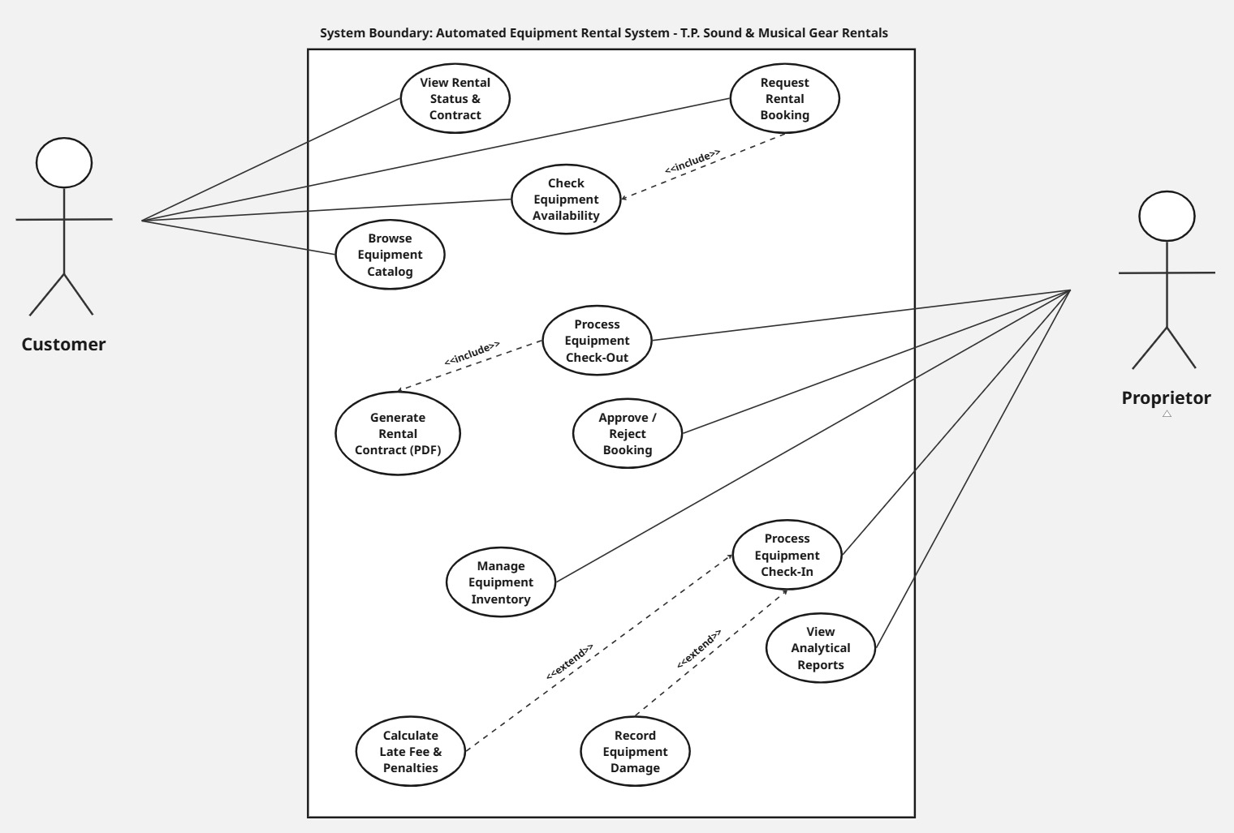
Figure 5.1: Use Case Diagram for T.P. Sound & Musical Gear Rentals

5.2 Summary of System Use Cases
Use Case ID | Use Case Name | Primary Actor | Description
UC-01 | Browse Equipment Catalog | Customer | Customer browses equipment catalog and filters items by category.
UC-02 | Request Rental Booking | Customer | Customer selects dates and submits a booking request.
UC-03 | Check Equipment Availability | System / Customer | System checks for booking date overlaps to prevent double-booking.
UC-04 | View Rental Status & Contract | Customer | Customer tracks booking status and previews rental contract.
UC-05 | Approve / Reject Booking | Proprietor | Proprietor reviews and approves or rejects pending requests.
UC-06 | Process Equipment Check-Out | Proprietor | Proprietor issues equipment and collects initial deposit.
UC-07 | Generate Rental Contract (PDF) | System / Proprietor | System automatically generates the PDF legal agreement.
UC-08 | Process Equipment Check-In | Proprietor | Proprietor receives returned equipment and initiates return settlement.
UC-09 | Calculate Late Fee & Penalties | System / Proprietor | System computes overdue days and calculates late return charges.
UC-10 | Record Equipment Damage | Proprietor | Proprietor assesses physical condition and logs damage expenses.
UC-11 | Manage Equipment Inventory | Proprietor | Proprietor adds, updates, or removes equipment items.
UC-12 | View Analytical Reports | Proprietor | Proprietor reviews business metrics, revenue, and active rentals.

5.3 Detailed Use Case Specifications

UC-01: Browse Equipment Catalog
- Actor: Customer
- Pre-condition: Application catalog page is loaded in the browser.
- Main Flow:
  - Customer navigates to the equipment catalog page.
  - Customer selects a category filter or enters a search keyword.
  - System displays the filtered equipment list with daily rental rates and current availability status.
- Post-condition: Equipment catalog is displayed based on customer filter criteria.

UC-02: Request Rental Booking
- Actor: Customer
- Pre-condition: Desired equipment item is selected from the catalog.
- Main Flow:
  - Customer selects the intended rental start date and end date.
  - System triggers availability verification for the chosen date range.
  - System calculates the total rental fee and appends the standard refundable security deposit.
  - Customer provides contact details (Name, NIC, Contact Number) and submits the request.
  - System creates a booking record with a unique Booking ID and sets status to Pending Approval.
- Post-condition: Booking request is logged and displayed under pending approvals on the dashboard.

UC-03: Check Equipment Availability
- Actor: Customer / System
- Pre-condition: Rental start and end dates are selected by the customer.
- Main Flow:
  - System queries the reservation database for the selected equipment item.
  - System compares requested dates against existing active and approved bookings.
  - System returns confirmation of availability or alerts user if a booking collision occurs.
- Post-condition: Equipment availability status is verified for the requested date range.

UC-04: View Rental Status & Contract
- Actor: Customer
- Pre-condition: Customer has an active or pending booking request.
- Main Flow:
  - Customer accesses the booking tracking lookup interface.
  - Customer enters their Booking ID or registered contact phone number.
  - System retrieves and displays the current booking status and rental summary.
- Post-condition: Customer views current booking status and contract details.

UC-05: Approve / Reject Booking
- Actor: Proprietor (Mr. Tony Prabath)
- Pre-condition: Customer booking request is in Pending Approval status.
- Main Flow:
  - Proprietor views the pending booking requests list on the Admin Dashboard.
  - Proprietor inspects customer details, rental dates, and requested equipment.
  - Proprietor selects Approve or Reject for the booking request.
  - System updates booking status in the database and reserves equipment dates if approved.
- Post-condition: Booking status is updated to Approved or Rejected.

UC-06: Process Equipment Check-Out
- Actor: Proprietor
- Pre-condition: Customer arrives at shop and booking status is Approved.
- Main Flow:
  - Proprietor selects the approved booking record from the dashboard.
  - Proprietor confirms receipt of refundable security deposit.
  - System executes PDF contract generation for the active session.
  - Proprietor issues physical equipment and confirms check-out.
  - System updates equipment status to Rented and booking status to Active.
- Post-condition: Equipment status changes to Rented and rental period officially commences.

UC-07: Generate Rental Contract (PDF)
- Actor: Proprietor / System
- Pre-condition: Booking check-out is initiated by the proprietor.
- Main Flow:
  - System extracts customer details, equipment list, rental dates, and financial breakdown.
  - System injects standard terms, loss liability clauses, and deposit conditions.
  - System compiles and renders a downloadable PDF agreement.
- Post-condition: PDF rental agreement is generated and ready for export.

UC-08: Process Equipment Check-In
- Actor: Proprietor
- Pre-condition: Equipment is returned to shop under an Active rental contract.
- Main Flow:
  - Proprietor locates active booking record using Booking ID or Customer Phone Number.
  - System compares actual return date with agreed contract return date.
  - System initiates late fee calculation if the return date is past the due date.
  - Proprietor inspects equipment condition and logs damage charges if applicable.
  - System computes Net Settlement Amount after deposit deductions.
  - Proprietor confirms return settlement.
  - System sets equipment status to Available and updates booking status to Completed.
- Post-condition: Equipment returns to available inventory and financial settlement is completed.

UC-09: Calculate Late Fee & Penalties
- Actor: Proprietor / System
- Pre-condition: Equipment return date exceeds agreed contract end date.
- Main Flow:
  - System calculates total overdue days past contract due date.
  - System multiplies overdue days by configured daily rental rate.
  - System displays calculated late penalty amount on check-in interface.
- Post-condition: Overdue penalty fee is calculated and added to return settlement.

UC-10: Record Equipment Damage
- Actor: Proprietor
- Pre-condition: Physical inspection reveals damage or missing components during check-in.
- Main Flow:
  - Proprietor selects damage option on return panel.
  - Proprietor enters damage description and monetary repair charge.
  - System adds damage cost to overall deductions against security deposit.
- Post-condition: Damage notes and penalty costs are recorded in booking log.

UC-11: Manage Equipment Inventory
- Actor: Proprietor
- Pre-condition: Proprietor is logged into the administrative interface.
- Main Flow:
  - Proprietor opens the inventory management interface.
  - Proprietor chooses to add new equipment, edit existing item details, or adjust item status.
  - System validates input data and updates equipment records in the database.
- Post-condition: Inventory database is updated and changes reflect on public catalog.

UC-12: View Analytical Reports
- Actor: Proprietor
- Pre-condition: Proprietor is logged into the administrative interface.
- Main Flow:
  - Proprietor accesses the analytical reports section on the dashboard.
  - System calculates and displays operational metrics, total revenue, active rental counts, and overdue statistics.
- Post-condition: Business analytics and performance metrics are rendered on screen.

ASSUMPTIONS AND CONSTRAINTS

6.1 System Assumptions
- User Device & Internet Accessibility: It is assumed that both the proprietor and customers have access to a standard web browser (e.g., Google Chrome, Mozilla Firefox) and a stable internet connection to interact with the system.
- Single-Owner Operational Workflow: The system design assumes that the primary administrative user is the proprietor (Mr. Tony Prabath) managing all approval, check-out, and check-in workflows directly.
- Accurate Manual Data Entry: It is assumed that the customer provides accurate personal information (Name, Contact Number, NIC) during the booking process and that the proprietor accurately inputs any physical gear damage costs during check-in.
- Physical Inspection Priority: The system assumes that physical equipment condition checks are performed manually by the proprietor upon return prior to confirming the check-in settlement on the system.
- Currency and Rates: All financial calculations, daily rental charges, deposits, and late penalties are assumed to be processed in Sri Lankan Rupees (LKR) under fixed daily rate rules.

6.2 System Constraints
- Single-Location Scope: The current implementation is constrained to a single business location and does not support multi-branch inventory transfers or multi-store stock syncing.
- No Direct Online Payment Gateway: Due to scope and SME requirements, the system does not process direct credit/debit card online payments; rental fees and deposits are settled via cash or manual bank transfer upon gear hand-over.
- PDF Contract Rendering: Dynamic PDF rental agreements are generated client-side/server-side using pre-defined legal templates; custom layout modifications by the proprietor are restricted to pre-configured fields.
- Fixed Delay Penalty Rate Rules: Late return penalty calculations strictly follow standard daily rate multipliers and do not dynamically adjust for partial-day or hourly delays.
- Deployment & Hosting Limits: The system is hosted on free/low-cost cloud infrastructure tier (e.g., Render/Vercel and MongoDB Atlas), which may introduce minor initial spin-up latency after idle periods.

INITIAL USER INTERFACE CONCEPTS

This section outlines the primary user interface (UI) wireframes and conceptual mockups for the proposed rental management system. The design emphasizes a responsive, clean, and modern layout tailored for both end-customers and internal system management.

7.1 Customer Portal Concepts
The Customer Portal provides a public-facing interface where users can browse available audio equipment, view daily rental rates, check availability, and place booking requests.
- Main Landing & Catalog Page: Displays item categories, active inventory, daily rates, and a search filter.
- Booking Request Interface: Allows users to select rental duration dates, specify quantity, view an estimated total cost calculation, and submit booking requests with required identity details.
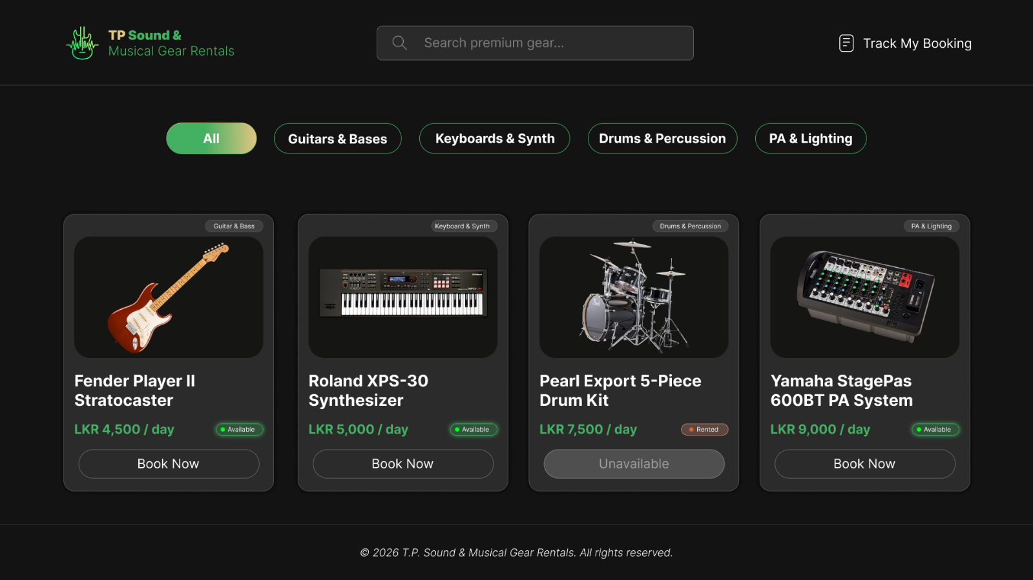
Figure 7.1: Customer Portal Interface and Equipment Catalog

7.2 Administrative Dashboard Concepts
The Admin Dashboard is designed specifically for the proprietor to manage daily operations, track rental workflows, and inspect inventory status effectively.
- Dashboard Overview: Displays real-time operational metrics including pending booking approvals, active rentals, pending returns, and total system inventory.
- Inventory & Fleet Management: Enables full CRUD (Create, Read, Update, Delete) operations for equipment items, maintenance status toggling, and base rate updates.
- Check-In / Check-Out Workflows: Interactive management screens to confirm gear hand-overs, apply manual damage penalties during returns, and trigger final invoice generation.
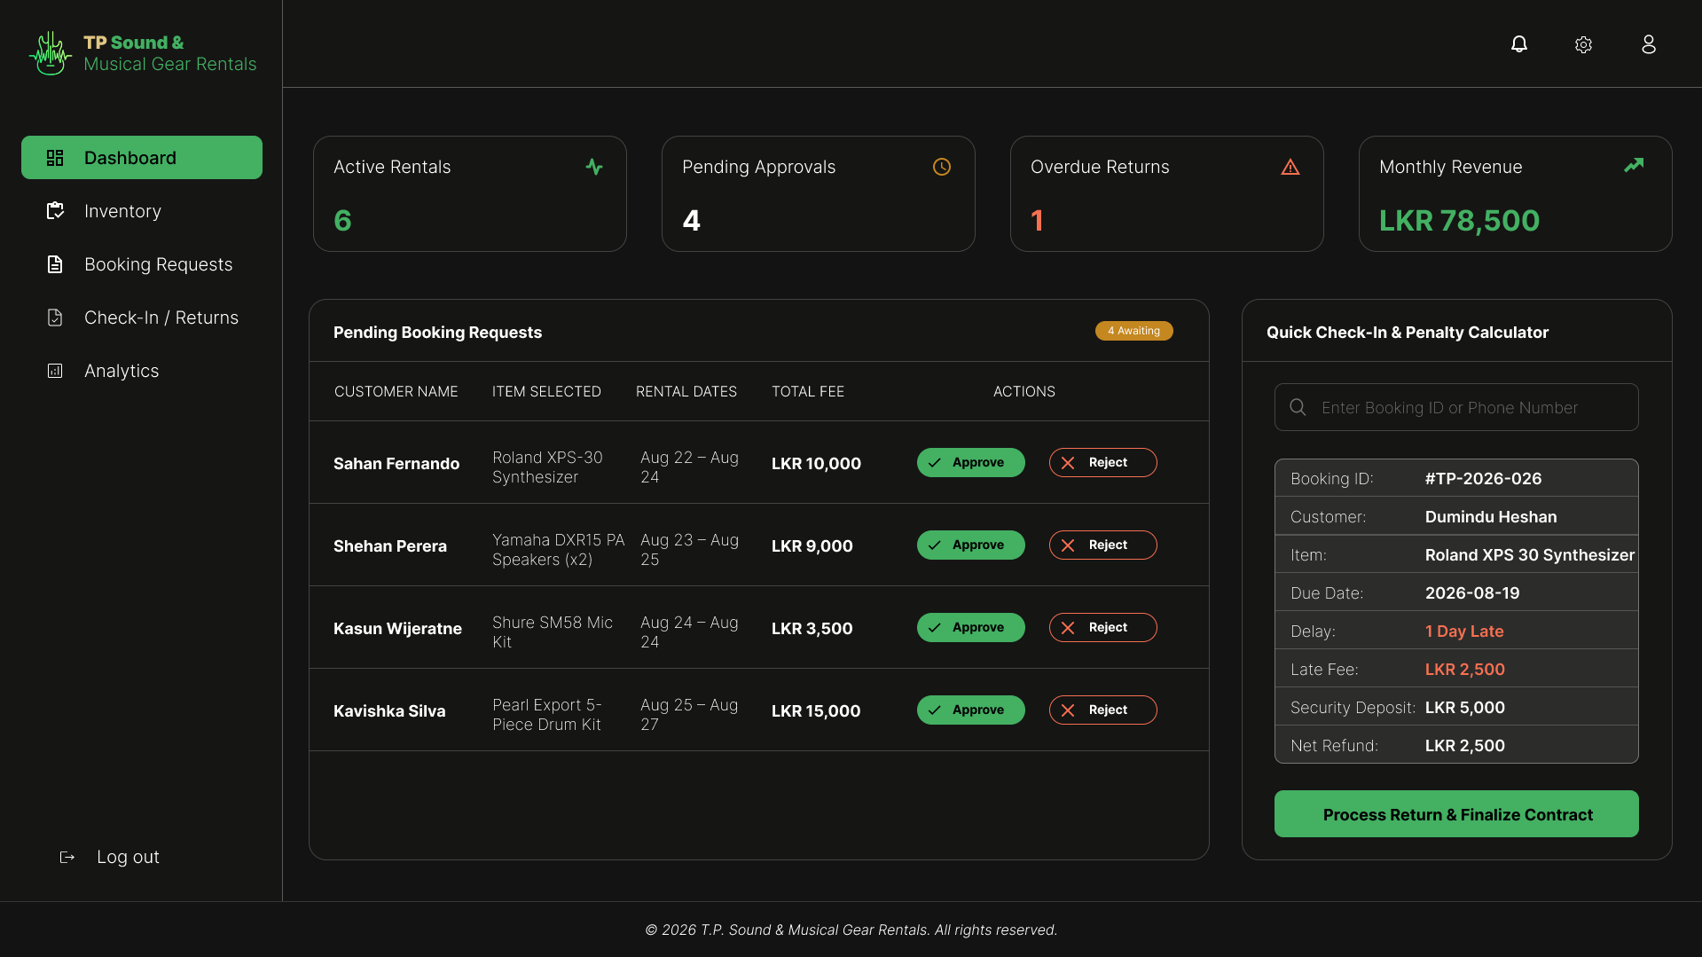
Figure 7.2: Administrative Dashboard Overview

7.3 Popups & Modal Windows
Modal dialogs are utilized to perform quick administrative actions without navigating away from the current workspace view.
- Generate Contract / Settlement Popup: A dedicated modal overlay that displays pre-filled contract details, calculated itemized costs, and damage fee inputs before generating the final PDF rental agreement.
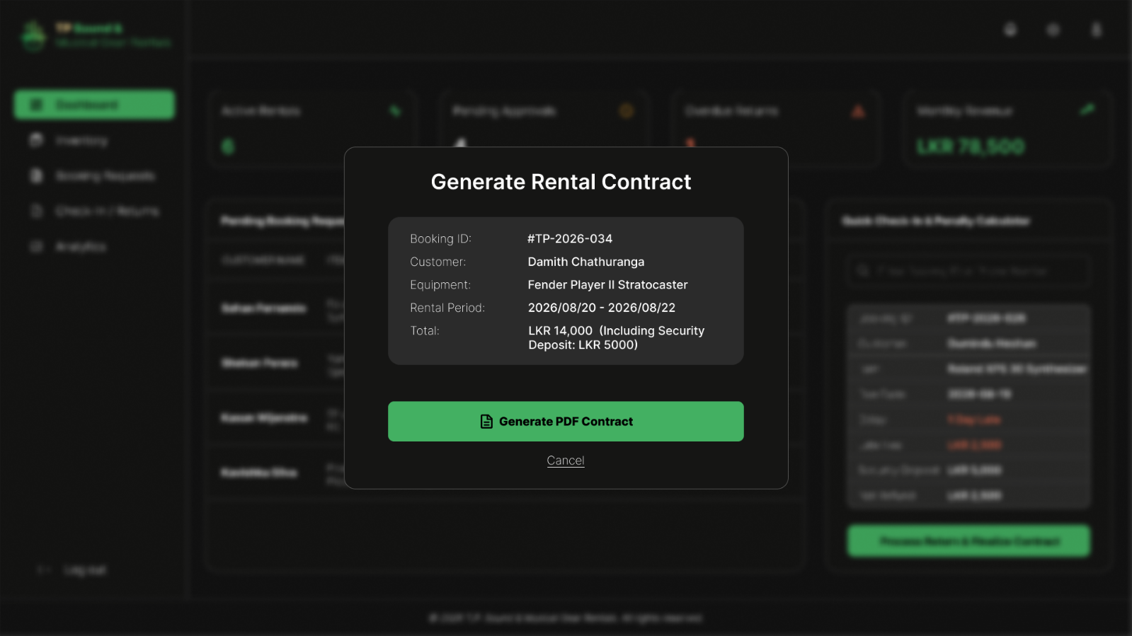
Figure 7.3: Rental Contract Generation Modal Window

Interactive Figma Prototype & Wireframes Link: Click Here to View Figma Design

Appendix B: References and Supporting Materials

1. System Specifications & Templates
- OUSL Software Engineering Guidelines. (2026). Preliminary Software Requirements Specification (SRS) Template. Open University of Sri Lanka.
- IEEE Computer Society. (1998). IEEE Std 830-1998: IEEE Recommended Practice for Software Requirements Specifications. IEEE Standards Association.

2. Technology Stack & Framework Documentation
- React Documentation. (2026). React – A JavaScript library for building user interfaces. Meta Open Source. https://react.dev/
- Node.js Foundation. (2026). Node.js Documentation & Architectural Best Practices. https://nodejs.org/
- Express.js. (2026). Express - Minimalist Web Framework for Node.js. https://expressjs.com/
- MongoDB Inc. (2026). MongoDB Atlas & Schema Design Principles. https://www.mongodb.com/docs/

3. Libraries & Deployment Infrastructure
- PDFKit. (2026). PDF Document Generation Library for Node.js. https://pdfkit.org/
- Render & Vercel. (2026). Cloud Hosting & Deployment Documentation. https://render.com / https://vercel.com

Appendix C: AI Usage Declaration

Declaration on the Use of Generative AI Tools:
Generative AI tools (Google Gemini and DeepSeek) were utilized during the development of this project proposal and Preliminary Software Requirements Specification (SRS) document under the following operational scopes:
- Google Gemini: Utilized during the system analysis and documentation phases for refining project descriptions, structuring academic SRS sections, generating standardized IEEE-compliant specifications, and formatting technical text.
- DeepSeek: Employed during the architecture and planning phases for code logic optimization, date-and-penalty calculation validation, and validating database schema design for the rental workflow.

Note: All core system ideas, domain workflows for T.P. Sound & Musical Gear Rentals, database models, and functional requirements remain original work designed specifically for the target business.

Appendix D: Individual Member Contribution Breakdown

We hereby declare that all four team members actively collaborated to complete the documentation of this Project Proposal and Preliminary Software Requirements Specification (SRS) for T.P. Sound & Musical Gear Rentals. The individual report writing and research contributions are detailed below:

- Student 01: P.A.Y. Ekanayake (Reg No: 424705860)
  - Documentation Scope: Project Background, Problem Statement, Objectives, Existing Systems Analysis (Booqable/EZRentOut comparison), and UI/UX Concept Designs (Figma Wireframes).
- Student 02: S.D.K.K. Saputhanthri (Reg No: 324703649)
  - Documentation Scope: System Use Case Diagrams, Detailed Use Case Specifications (UC-01 to UC-12), Non-Functional Requirements, and Functional Requirements.
- Student 03: B.G.N.H. Bokanda (Reg No: 424704542)
  - Documentation Scope: System Functional Scope & Risk Analysis, Contract Automation Specs (PDF Generation), System Assumptions & Constraints, IEEE References/Formatting, and AI Tools Usage Declaration.
- Student 04: W.K.V. Dilthara (Reg No: 324702072)
  - Documentation Scope: Technology Stack Overview, System Architecture, Dynamic Penalty Calculation Rules, Work Breakdown Structure (WBS), and Project Timeline.

Joint Declaration: All team members listed above have reviewed, confirmed, and agreed upon the documentation contribution breakdown stated in this report.

-END-

